

Giaffo Designs

Plugin Guide

v 1.5.7

Color FX Engine

Contents

Plugin Overview 3

System Requirements 3

DISCLAIMER: 3

Plugin Use 4

1-1: Importing the Color FX Engine 4

1-2: Functions of Each Plugin 4

2-1: Installation Setup 5

2-2: Engine Installation 7

3-1: Engine User Config Setup 10

3-2: Using the Color FX Engine 11

3-3: Customizing the Color FX Engine 14

3-4: Updating for a New Rig 15

4-1: Uninstalling the Color FX Engine 15

Advanced Use 16

Extra User-Config Settings 16

Altering the Installation 17

Adding/Removing Color Presets 17

FAQ 18

Release Notes 19

# Plugin Overview

The Color FX Engine Plugin is a GrandMA2 plugin that builds a dynamic color effect page. This page allows the user to quickly setup and change color effects on the fly during show operation. The plugin is designed to allow for greater variety of easy-to-access color effects during a punted lighting show.

# System Requirements

* GrandMA2 version 3.2.2.16 or later.

# DISCLAIMER:

GIAFFODESIGNS AND ITS PRODUCTS ARE IN NO WAY AFFILIATED WITH OR REPRESENTATIVE OF MA LIGHTING OR ANY OF ITS SUBSIDIARIES.

BY USING THIS PLUGIN YOU AGREE THAT GIAFFODESIGNS IS NOT TO BE HELD LIABLE FOR DAMAGES RESULTING FROM ANY PLUGIN MALFUNCTIONS. ALWAYS TEST PLUGINS BEFORE USING THEM IN A LIVE SETTING.

# Plugin Use

## 1-1: Importing the Color FX Engine

The Color FX Engine is packaged as a multi-part plugin. The plugin script cannot be copied and pasted into the Plugins Pool the way that individual plugins can. The MA2 built-in Import plugin function must be used. *(For more detailed help with this, refer to the* *GiaffoDesigns Multi-Export Plugin.)*

To import the Color FX Engine, first find four consecutive empty slots in the Plugins Pool. *Note: if there are already plugins stored to any of these four consecutive pool items, they will be overwritten. This cannot be undone or “Oops-ed.”* Right click the first of these pool items and use the Import button to import to import the plugins. Click Save before exiting the Edit Plugin menu. Four plugins should have been imported into the Plugins Pool.

## 1-2: Functions of Each Plugin

The three plugins that were imported into the Plugins Pool each have a unique function for the Color FX Engine (please note that as of v1.3 the GDF file is no longer imported as it has been embedded in the other plugins):

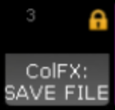ColFX: SAVE FILE

This plugin contains all of the settings and data needed for the Color FX Engine to run. It is referenced by name in the ColFX Engine Plugin and is therefore locked to avoid accidentally altering the file. This plugin should not be unlocked or altered in any way.

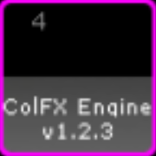ColFX Engine

This plugin runs the Color Effect Engine after installation. It includes a handful of user-configurable options (discussed later) and has the ability to change installation-related settings after the initial install, if necessary.

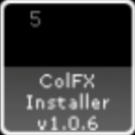

ColFX Installer

This plugin installs the Color FX Engine into the show file.

## 2-1: Installation Setup

Before installing the Color FX Engine, there are a few user variables that can to be verified. The plugin will function with default variables, but edits can be made to specify where data is stored. The plugin will automatically skip over pool items that are already in use in order to avoid overwriting data. To manually set the user-configurable variables, Edit the ColFX Installer plugin and review the following:

-------- INSTALLATION SETTINGS --------

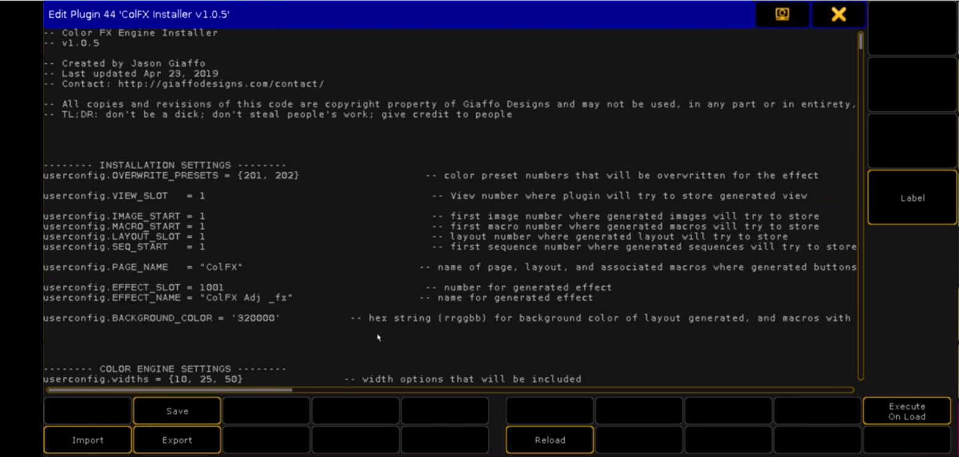

*These settings will affect the names, locations, and appearance of generated content.*

* userconfig.OVERWRITE_PRESETS defines the Color Preset numbers that will be created or overwritten by the Color FX Picker to use as the base values for color effects. These presets will be continually updated by the generated Color Picker layout. If more than two values are provided, only the first two will be used for the generated effect. This variable should have two (or more) numbers inside the brackets separated by a comma.  
  EXAMPLE: {31, 32}
* userconfig.VIEW_SLOT defines an empty slot in the View Pool where the plugin will store the generated Color FX view.
* userconfig.IMAGE_START defines the starting Image Pool number that will be used to store the images for the Color FX Picker.
* userconfig.MACRO_START defines the starting Macro Pool number that will be used to store the macros that the Color FX Picker layout triggers.
* userconfig.LAYOUT_SLOT defines the Layout Pool number that will be used to store the Color FX Picker layout.
* userconfig.SEQ_START defines the first sequence number that will be used by the plugin. If the sequence using this pool number is already in use, the plugin will use the next available sequence.
* userconfig.PAGE_NAME defines the label for the page, layout, and associated macros to which the buttons generated by the plugin will be stored.
* userconfig.EFFECT_SLOT defines the Effect Pool item number that will be used to store the generated effect.
* userconfig.EFFECT_NAME defines the label that will be assigned to the generated color effect. This is the label that the Color FX Engine macros and sequences will reference when updating the effect.
* userconfig.BACKGROUND_COLOR defines the background color that will be assigned to the generated layout, expressed as an hex value rrggbb.

EXAMPLES:

* 320000 (dark red, default)
* 000000 (black)
* ff007f (saturate purple)

-------- COLOR ENGINE SETTINGS --------

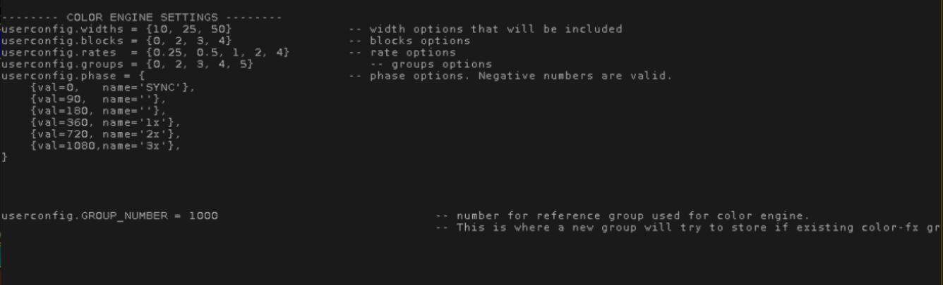

*The Color FX Engine creates a handful of sequences that each update the running color effect. These settings will affect the options that are available in those created sequences to modify the effect in the Color FX Engine.*

* userconfig.widths – *width* options for the generated color effect.
* userconfig.blocks – *block* options for number of blocks in the color effect.
* userconfig.rates – *rate* options for generated color effect.
* userconfig.groups – *groups (interleaves)* options for groups in the effect.
* userconfig.phase – *phase* options for the effect. Values (*val* field) can be positive or negative numbers. Each value will be used in the plugin to set the phase from that number through zero. The name, in single quotation marks, will be what appears as the label for this phase setting in the sequence cue stack. The “name” field is optional and can be left as empty quotes.  
  EXAMPLES:
* {val=360, name=’1x’} will create an option in the Color FX Engine for a phase of **360 to 0**, and that option will be labelled in a cue stack as **1x**. The effect will run in order from the first selected fixture to the last.
* {val=-360, name=’-1x’} will create an option for a phase of **-360 to 0**, and that option will be labelled in a cue stack as **-1x**. The effect will run in reverse order, going from the last fixture in the selection to the first.
* {val=180, name=’’} will create an option for a phase of **180 to 0** and that option will be labelled in a cue stack as **180**, because no value was given for a name.
* userconfig.GROUP_NUMBER defines the base reference group used for the Color FX Engine. As groups of fixtures are selected and deselected to be included in the running effect, the plugin will update this base group with those fixtures. After the Color FX Engine is installed, the group will be referenced by name rather than pool item number. It can therefore can be moved anywhere in the pool, but should not be renamed.

## 2-2: Engine Installation

The Color FX Engine Installer will ask for some data input, which should be pulled up in windows or written down in preparation.

1. Color Presets: The Color Preset Pool should be open on a screen and should be showing the colors that are going to be desired as options for values in the generated color effect. Alternatively, the preset numbers should be written down.
2. Groups: The Groups Pool should be open in a screen and showing the groups of fixtures that are going to be included as options for the generated color effect. This can include, for example, a group that includes all spot fixtures, one that includes all wash fixtures, and one for all beam fixtures. Alternatively, the group numbers should be written down.
3. Selection-Order Groups: [Optional] Selection Order groups should be created and either visible in the Groups Pool or written down. Selection Order groups should include all fixtures in the rig that might be used by the Color FX Engine, selected in unique orders. For example, some desirable selection orders might be a snake pattern through the trusses, or selecting the entire rig from left to right or right to left.
4. Executor Page: Determine and write down an empty executor page number that can be used for the Color FX Engine to store all generated sequences.
5. Effect Executor: Determine and write down the executor number, including page number, where the generated effect will be stored. This is the effect that will be used as the base for the Color FX Engine. All generated executors and other content will edit the settings of this effect. For example, if a punt page in a show file is stored on page 90, then executor 90.15 might be used for the generated color effect to make it easily accessible when punting a show.

Once these items have been prepared and/or documented, click on the ColFX Installer plugin in the Plugins Pool to begin installation. This should be the fourth of the plugins that were imported into the show file.

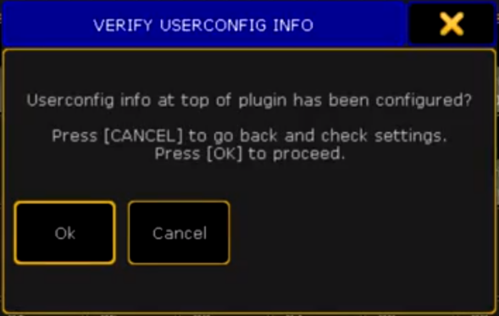

A message will appear with a reminder to check User-Config Settings in the plugin script. Press [Please] to continue.

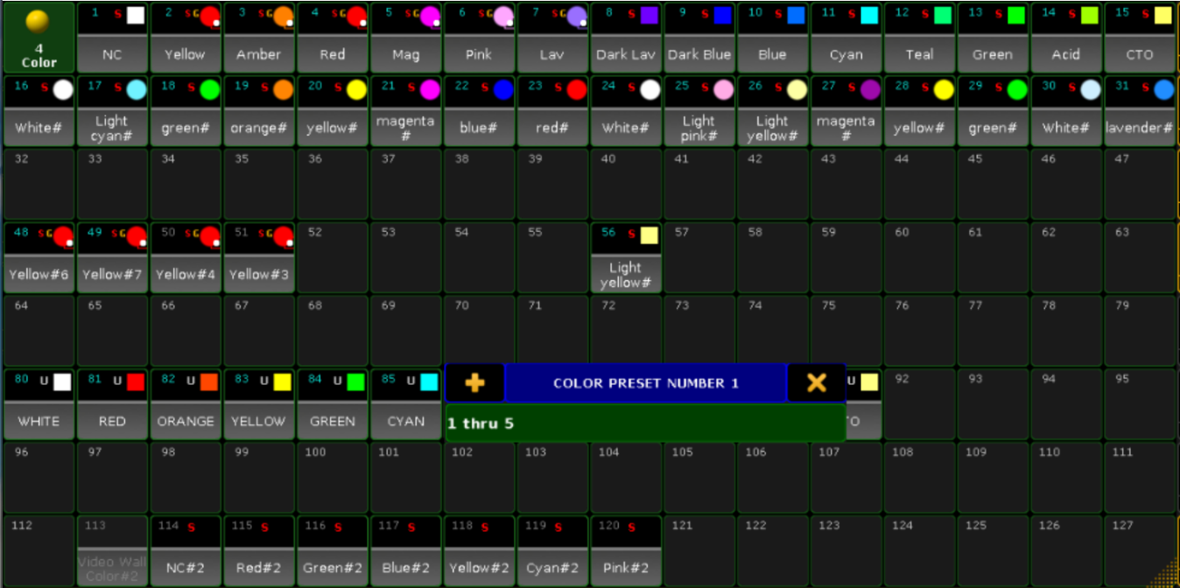Next, input the pool item number of the color presets to be used as reference for the layout. Numbers can be input individually, followed by [Please], or as a group, for example 1 thru 5.Once all pool items have been entered, press [Please] one more time.

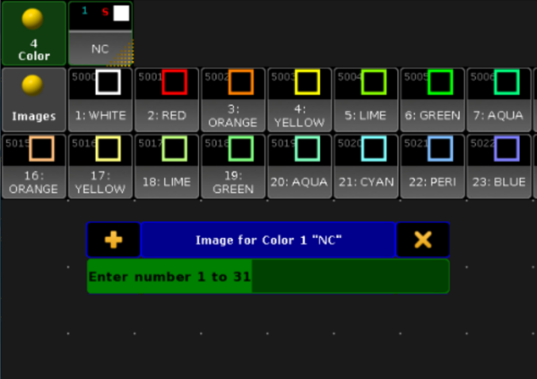

Screen 2 will populate with an open Image Pool. The images shown in the pool are options that will be used to correspond to color presets in the Color FX Picker layout. Match the color preset listed in the popup window with the number label of a matching image, type the number label of the image into the popup, and press [Please].

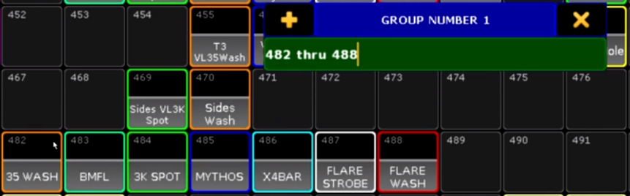The pop-up will now ask for Group Number input. Enter the pool number for each group that will be included as options for the generated color effects view, followed by [Please]. Press [Please] once more when finished.

Next, the pop-up will ask for Selection Order Groups. If desired, enter the pool number for the groups containing specific selection orders, followed by [Please]. As previously stated, this step is optional and can be bypassed by pressing [Please] without inputting any text. After entering desired groups, press [Please] to move on to the next step.

Input the executor page number to which all generated executors will be stored and press [Please]. If the page has already been used, a conflict warning will appear displaying any executors already on the page and asking for permission to overwrite executors and rename the page. Press Cancel to enter a different page number, or **Ok** to overwrite that page.

Input the executor number to which the generated effect will be stored, followed by [Please].

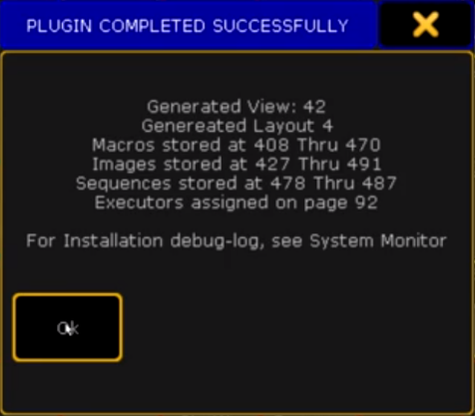

There will be a short pause as the plugin generates all content.

Once the installer has finished running, a confirmation window will appear. This window will display the locations of all generated content relating to the Color FX Engine.

The Color FX Engine view will open in Screen 2, including a layout window and all associated executors. The Color FX layout will not yet be open in the Layout View window on the page. It must be selected with the dropdown menu in the top-right corner of the Layout View window. This screen can now be stored as an update to the View that the installer generated or stored as a new view in the sidebar.

**PLEASE NOTE:** Once installation is complete, you may have to reload your plugin engine for the engine to work. To do this, edit any plugin object and hit the Reload button, or type the ReloadPlugins keyword into the command line.

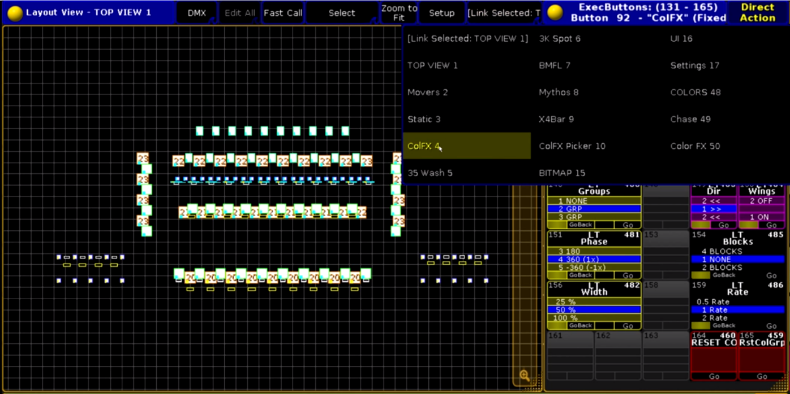

## 3-1: Engine User Config Setup

Now that the Color FX Engine View Page has been installed, the ColFX Engine plugin can be edited to set a few User Config Variables. There are three main variables that need to be edited. The rest of the variables in this section are not necessary in most cases, and are therefore explained in the Advanced Use section of this manual. The three variables to be edited are:

* userconfig.SM_BPM defines a speed or rate master that will be used for the color effect when there are 2 groups or more used in the effect (aka “step-based” effects). This number can be a speed-master (3.X) or a rate-master (4.X).
* userconfig.SM_FLOW defines a speed or rate master that will be used for the color effect when the effect is set with 0 groups (aka “flow-y” or “smooth” effects). This can be set to the same master as the SM_BPM variable. This number can be a speed-master (3.X) or a rate-master (4.X).
* userconfig.RATE_FLOW defines the default rate that will be applied when groups = 0 in the effect. By default, this is set to 0.25, but can be set to any number greater than 0.

Once these User Config Variables have been defined, click Save and close the Edit Plugin window.

## 3-2: Using the Color FX Engine

### **Color FX Layout**

### 

On the left half of the created view is the Color FX Layout. The main portion of this layout taken by the rows of color presets (b), which were selected during installation. The first row of colors will change the low value in the color effect, and the second row will change the high value in the effect. Any additional rows (if added) will not influence the effect. When a color in the layout is selected, the original color preset is copied to the preset that the color effect references for its high or low value. The image will update to show the active color for that preset.

Below the color preset rows are a series of macros that change the effect waveform (c). These include Sine, Triangle, Ramp Up, Ramp Down, Step, Short Fade, and Medium Fade. The currently selected macro will be indicated by the symbol in the top right corner and will show that it is running Line 3 of the macro. Note that *Ramp Up* and *Ramp Down* will reset the *Direction* executor to ensure the ramp is not reversed.

In the top left corner of the layout, there is a ColFX Info macro (a). This will bring up information related to the plugin installation in both the Command Line Feedback window and any open Info window. Information displayed will include location of macros, sequences, and layouts that were generated by the ColFX Installer plugin. Most importantly, it includes the location of the Uninstaller Macro, in case at any point in time it is necessary to completely uninstall the Color FX Engine from the show file.

### **Color Engine Executors**

### 

The right half of the Color FX Engine view is taken up by a series of executors. These executors all change a different parameter of the generated color effect.

1. The top two rows in this section are macros that toggle on and off individual fixture groups. To include a group of fixtures in the effect, click the macro with that group’s label. It will turn blue to indicate that the group is now part of the running effect. To remove that group from the effect, click the macro again and it will turn red to show that the fixture group is no longer included in the effect. The last executor of this set, labelled SHUFFLE, will shuffle the selection order in the effect.
2. The Presets sequence can be used to store multiple effect settings (for example, a specific setting for phase, width, and rate), to be quickly recalled all at once. This sequence will be left empty after initial installation. Adding Color FX Engine Presets will be discussed in Section 3-3: Customizing the Color FX Engine.
3. The Groups sequence affects the grouping of fixtures in the running effect.
4. The Phase sequence alters the phase across the fixtures in the effect. The phase will be the number labelled in the cue, with the optional customized label from the Installer plugin included in parentheses.
5. The Width sequence changes the effect width.
6. The Selection Order sequence will include a cue for each of the selection order groups that were input during installation. It also includes a cue 0.5 “NONE” to be used when none of the other selection orders are desired. *Note: Due to the way that this feature is programmed, if no fixture groups are toggled on to be included in the running effect, all fixtures from the* Selection Order *cue will be used in the effect at that moment.*
7. The Dir sequence will change the direction of the effect from running forwards to backwards.
8. The Wings executor will toggle wings on and off, for use with a selection order that goes from one side of the rig to the other.
9. The Blocks sequence changes the number of blocks in the effect.
10. The Rate sequence serves as a rate multiplier for the effect. With a given bpm or speed, changing the rate can effectively double or halve the speed at which the effect runs.
11. RESET COLFX macro will reset all of the effect-parameter executors to default values. To see which cues each sequence is using as a default, right click on the macro. These defaults can be changed to any desired cue numbers.
12. The RstColGrp macro removes all fixtures from the effect and resets all group-selection macros. Use this every time you re-load your file, as there is no way of telling which group macros were last running.

## 3-3: Effect Executor

The Color FX Engine will edit parameters of the effect that were defined during installation. To re-locate the effect executor, run the ColFX Info macro in the Color FX layout and look for the effect location in the Command Line (“Effect Assigned to Executor…”). This executor is the master output control for the effect, which means parameters can be edited “blind” while the fader is down.

Be mindful to also have access to the speed-/rate-masters you designated in the effect engine plugin (userconfig.SM_BPM and userconfig.SM_FLOW)

## 3-3: Customizing the Color FX Engine

All of the macros and sequences used in the Color FX Engine have been designed to be easy to understand and manipulate by the user. This allows options for the effect parameters to be added, removed, or changed as needed.

Forms

The plugin is set up to use forms as either an inverse cosine or PWM wave, with altered attack and decay times that change the waveform into the designated shape. By default, the Sine form is actually an inverse cosine wave (this allows smoother shifts between effect settings). All other waveforms are a PWM with attack and decay modifications. Any number in the form’s macro line that is not 9 (inverse cosine) will be read by the plugin engine as a PWM form, regardless of the actual number.

Fixture Groups

To change which group of fixtures is referenced for each of the fixture group macros, edit the macro and change the number inside the parentheses of both lines 1 and 3 to reflect the new group number. This can also be used to add new groups to the fixture group section of the engine by replacing the 0 in lines 1 and 3 of an unused fixture group macro to reflect a new group, then relabel the macro with the group name.

Selection Order

To add a new selection order to the Selection Order sequence, store a new cue to the sequence and copy the text in the Command column of the cue list into the new cue. Then, replace the number in parentheses with the group number to be used for selection order in this cue. Relabel the new cue to reflect the new selection order.

To delete a selection order, simply delete the cue containing that selection order.

Groups, Phase, Width, Wings, Blocks, and Rate

To add a new group, phase, width, wings, blocks, or rate parameter, create a new cue in the designated sequence. Copy the text from the Command section of another cue in the sequence into the new cue and replace the number with the new desired value for that parameter. Then, relabel the new cue to reflect the new parameter.

To delete one of these options, simply delete the cue containing that setting from the designated sequence.

Presets

To add Color FX Engine presets to the Presets sequence, copy the RESET COLFX macro and edit the copied macro to include desired effect parameters. Then, create a new cue in the Presets sequence and add Macro X (where X = the macro number for the macro containing desired Color FX Engine presets) into the Command section of the cue.

Color Effect Attributes

The color effect used by the Color FX Engine, by default, is set up to use RGBAW color mixing. It has five lines in the effect - one for each color-mix attribute. If fixtures in the rig have more color mixing capabilities, for example a Lime or UV or Hue channel, these can be added as new Attribute lines in the effect. Ensure that the Mode, Low Value, and High Value match that of the previous Attributes.

## 3-4: Updating for a New Rig

There are three things that need to be checked when using the Color FX Engine with a new lighting rig:

1. Update any color presets that are used in the Color FX layout to include color information for any new fixtures.
2. Update all fixture groups referenced by the group-selection macros, and/or update the group numbers being referenced in these macros. Remember to run the “Reset Color Groups” macro after this to make sure extra fixtures are not stuck in the effect.
3. Update the Selection Order groups in the Groups Pool to reflect the new lighting rig. This can be accomplished by updating the Group Pool items that are used for selection orders or by changing the group number referenced by each cue in the Selection Order sequence.

## 4-1: Uninstalling the Color FX Engine

If for any reason the Color FX Engine needs to be removed, there is an Uninstaller Macro that was created during installation of the engine. This macro will remove all layouts, sequences, images, macros, and effects that were created during installation of the Color FX Engine. It will not delete the View, in case the view has been moved to a different pool number or renamed, therefore the View will need to be manually deleted.

To locate this macro, click the ColFX Info button in the Color FX layout. Look for the number of the Uninstaller Macro. Run the macro to uninstall. A confirmation pop-up will appear (to prevent accidental uninstallation). Press [Please] to confirm the Uninstall process.

*Note: Uninstallation of the Color FX Engine cannot be undone or “Oops-ed.” Be sure to save a backup of the show file before uninstalling.*

# Advanced Use

## Extra User-Config Settings

The Color FX Engine comes with some complex User Configuration Settings that can be used to further alter or customize the Color FX Engine. Generally, these settings shouldn’t need to be reviewed or changed. However, users with more intricate show files might find them useful. To view and edit these settings, Edit the ColFX Engine plugin in the Plugins Pool and look below the line stating

"---(parameters you probably don’t need to worry about)---"

*Please note that changes to these settings cannot be undone. Be sure to save a backup of the show file before changing these settings.*

* userconfig.GROUP_READ defines the name of the reference group that the generated color effect uses. When fixture group macros in the Color FX Engine view are toggled on or off, the fixtures in that group are copied into or removed from the reference group. However, the name of that reference group can be changed, if desired, to make it easier to identify when cleaning up a show file. Any changes to this group’s name should be reflected here.
* userconfig.TEMP_GRP defines a temporary group that is created and then immediately deleted whenever changes to the fixture group selection are made. The plugin engine begins looking for an available Group Pool item starting at whatever variable is specified. If, for some reason, all possible groups after this number are currently in use, this variable can be changed to a lower number to allow the plugin engine to find an empty group.
* userconfig.PAUSE_TIME defines the time in seconds that reset macros pause any Safe File updates before resetting the effect parameters. By default, save-file is stored to every time a parameter of the plugin is updated. This involves re-writing the save-file plugin, writing an xml file, and importing both of them. When updating 12 parameters at once, as with the **RESET COLFX** macro, this would be a waste of processing power. As a result, this macro starts with a command to pause all save-file rewrites. The PAUSE_TIME variable defines how long the pause will last. At the end of the pause time, regardless of any changes, the save-file is updated with the current Color FX Engine values.

After changing any of these variables, Save the plugin and Reload the plugin engine.

## Altering the Installation

Sometimes, it may be necessary or desirable to change the name or location of objects that were created during the initial Color FX Engine installation. Beneath the  
“---(parameters you probably don’t need to worry about)---" section in the ColFX Engine plugin script, there is a section of code that is commented out (using two dashes --). This section of the plugin script can be used update the plugin engine with any changes that were made to the following parts of the Color FX Engine after installation:

Executor Page Name

If the Page containing all of the executors in the Color FX Engine has been renamed, the install.pg_name variable can be used to update the plugin engine to reference items on this new page. To do so, replace the text within the quotation marks after this variable to match the new Page name, delete the -- from the start of the line to un-comment the line of code, and click Save to update the plugin.

EXAMPLE:  
If the Executor Page was installed with the name ColFX and renamed to Color FX Engine, the plugin script would need to be changed from:

--install.pg_name = “ColFX”

to instead say:

install.pg_name = “Color FX Engine”

Effect Name

If the name of the color effect being used for the Color FX Engine is changed, the install.target_effect variable will update the plugin to continue using that effect. To do so, replace the text with in the quotation marks after this variable to match the new effect name, delete the -- from the start of the line to un-comment the line of code, and click Save to update the plugin.

Low and High Value Presets

If the two color presets being used as the high and low value for the color effect are moved to a different location in the Color Preset Pool, the install.pset_dest variable can be used to update the plugin with this change. To do so, replace the value of the variable with the new location of the color presets, delete the -- from the start of the line to un-comment the line of code, and click Save to update the plugin.

## Adding/Removing Color Presets

To remove color presets from the Color FX layout, enter the Setup mode in the layout and delete the unwanted objects.

To add color presets into the layout, install the Color FX Picker plugin (included with purchase of the Color FX Engine). The new generated color-effects-picker layout can be merge-copied (Copy /m) into the existing layout to be combined with the existing waveform macros. Ensure that the same two slots in the Color Preset Pool are used when re-installing the layout.

# FAQ

**Q: I’ve completed installation but none of the layout buttons are working. What’s wrong?**

A: Your plugin engine needs to be reloaded, kind of like after a system update. Edit any plugin object and hit the Reload button, or type the ReloadPlugins keyword into the command line.

**Q: Why isn’t the Image Pool appearing on my screen when the installer asks for color images?**

A: The Image Pool will open in Screen 2 of the GrandMA2 software. If using MA2 onPC, Screen 2 may be hidden under the current window.

**Q: Why isn’t the effect running after I update effect parameters?**

A: Make sure the fader that the effect is assigned to is pushed up. The effect is built to be linked to an executor rather than automatically running when parameters are active, to allow the user to set up the desired effect parameters before pushing the effect fader up to have it running on stage.

For additional help and resources, please visit [GiaffoDesigns.com](http://giaffodesigns.com/).

Color FX Engine tutorial videos can be found [here](https://www.dropbox.com/sh/7dbe1p19afedh2d/AABQbtGb9vvBznxbXMYmnnwta?dl=0).

# Release Notes

**v.1.5.7**: Released September 4, 2021

* FIXED: Save-file did not erase contents during uninstallation

**v.1.4.0**: Released June 7, 2020

* Ability to create “presets” from combinations of values added into the plugin

**v.1.3.0**: Released May 4, 2019

* ColFX and DimFX plugins combined into the same code base for matching operation between both plugins

**v.1.0.7**: Released April 29, 2019

* Removed option to update color presets within the Color FX Picker.
* Color FX Picker added as as part of the .zip plugin package. User can now re-install just this portion without affecting the rest of the engine installation.
* Removed install.group_read_backup from ColFX Engine settings.

**v1.0.6**: Released April 25, 2019

* Re-Organized ColFX Engine UserConfig section

**v1.0.4**: Original Plugin Release

To report any potential plugin bugs, please visit [GiaffoDesigns.com/contact](http://giaffodesigns.com/contact/).